**MID TERM III EXAMINATIONS 2024**

**MATHEMATICS**

**PRIMARY FIVE**

***Time allowed: 2 Hours 30 Minutes***

Name: ……………………………………………………………..Stream.……………………

|  |  |  |  |  |
| --- | --- | --- | --- | --- |
| **FOR EXAMINERS’ USE ONLY** | | | | |
| **QN. NO** | | **MARK** | | **SIGN** |
| **1-5** | |  | |  |
| **6-10** | |  | |  |
| **11-15** | |  | |  |
| **16-20** | |  | |  |
| **21-22** | |  | |  |
| **23-24** | |  | |  |
| **25-26** | |  | |  |
| **27 -28** | |  | |  |
| **TOTAL** |  | |  | |

***Read the following instructions carefully:***

1. This paper has **two** Sections: **A** and **B**.
2. Section **A**, has **20** short answer questions (40 marks)
3. Section **B** has **12** questions (60 marks).
4. Answer **ALL** questions. All answers to both Sections **A** and **B** must be written in spaces provided.
5. All answers must be written using a blue or black ballpoint pen or ink. Diagrams should be drawn in pencil.
6. Unnecessary alteration of work will lead to loss of marks.
7. Any handwriting that cannot be easily read, may lead to loss of marks.
8. Do not fill anything in the box indicated for examiner’s use only.

|  |  |  |
| --- | --- | --- |
| SECTION | EXAMINER’S MARK | T/L MARK |
| A |  |  |
| B |  |  |
| C |  |  |

**SECTION A (40 marks)**

1. Add ; 542 + 38
2. If set M has 4 elements, how many subsets can be got from set M?
3. Express **XXVIII** in Hindu Arabic numerals.
4. Simplify: $2 \frac{1}{2} +1\frac{1}{2}$
5. Convert 5km into metres.
6. Find the next number in the sequence.

23, 21,19,17, ____

1. Divide 1212 by 4 8. Convert 414five to base ten

9. What evening time is shown on the clock face below?

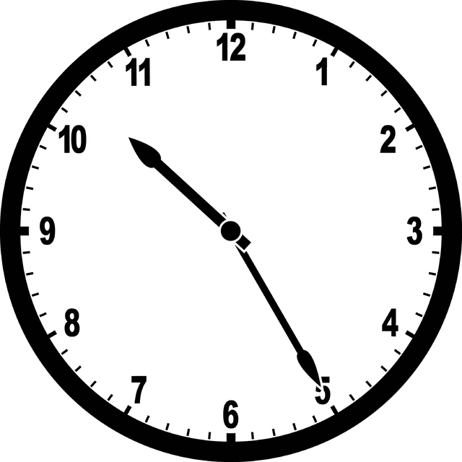

1. A basket has 6 red pens and 8 blue pens. What is the probability of choosing a red pen from the basket?
2. Simplify; 3m + 2m + m
3. If Hadija bought 8 mangoes at sh.2400. How much did she pay for each

mango?

1. A circular cup has a radius of 6cm. Determine its diameter.
2. If 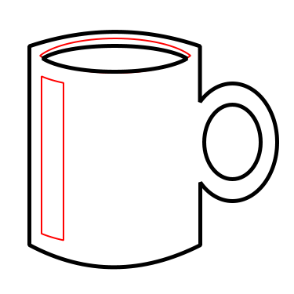 represents 10 cups, how many cups are represented by ?
3. Calculate the value of angel marked **X** in degrees.
4. Find the **LCM** of 8 and 6.
5. What number has been expanded to give **(3x1000)+(4x100)+(5x10)+(6x1)**
6. How many lines of folding symmetry has the shape below. (show them)
7. Patience is 10year and Aisha is 14 years. Find the average age of the two girls.
8. The rectangle below measures 16cm by 13 cm. Find its perimeter.

16cm

13cm

**SECTION B (60 marks)**

1. Give that set P = {1,2,3,4,5} and Q = {2,3,5,7,11}
2. Represent the above information on the Venn diagram below.(3 marks)

**P Q**

1. Find (i) P n Q (1 mark ) (ii) n (PuQ) (2 marks)
2. **Study the figure below and answer questions that follow.**
3. Find the area of the outer figure. (2marks)

9cm

1

15cm

b) Calculate the area of the triangle. (2marks) c)Find the area of the shaded region.

1. **Use the number line below to answer the questions that follow.**

X

Y

Z

1. Write the integers represented by the letters. (1 mark each )

**X** : _______________________

**Y** : _______________________

**Z** : ________________________

1. Write the Mathematical statement shown on the number line. (2marks)
2. Nalumansi went to the super market and bought the following items.

* 3tins of ice cream at sh.1000 each
* 4bans at sh.300 each ban.
* 2kg of sugar at sh.6000.
* 2packets of sweets at sh.3000 each packet.

1. How much did she spend on each item? (3marks)
2. Calculate her total expenditure.(2marks)
3. If she had sh.20,000. What was her balance?(1 mark)
4. a) Using a ruler, pencil and a pair of compasses only, construct an equilateral triangle of side 5cm. (3cm)

b) Work out the perimeter of the triangle above. (2marks)

1. Solve for the unknown.
2. M + 3 = 15 (2 marks ) b) 2k - 4 = 6 (2 marks)
3. a) Prime factorise 36 and give your answer in subscript form. (2 marks)
4. List all the factors of 24. ( 2marks)
5. Given the numeral 5,432.
6. What is the place value of 4 in the number above?
7. Find the difference between the value of 5 and the value of 3. ( 2marks)
8. a) Write the shaded fraction in its lowest form. (2marks)

|  |  |  |  |  |
| --- | --- | --- | --- | --- |
|  |  |  |  |  |
|  |  |  |  |  |
|  |  |  |  |  |

b) Convert $\frac{3}{5}$ to a decimal fraction. (2marks)

c) How many half litre cups can Mabel get from 10 litre bucket of juice?

1. a) A mathematics examination started at 8:15 am and ended at 11:00am. How long was the examination? (2marks)

b) Bolingo spent 84 days at school for first term. How many weeks did he spend at school. (2marks)

1. **a) R, S** and **T** shared 2,106 sweets equally. How many sweets did **R** get?

(2 marks)

1. Multiply 25 x 25 (2marks)
2. The picto-graph below shows the number of trees planted in Bududa last year.

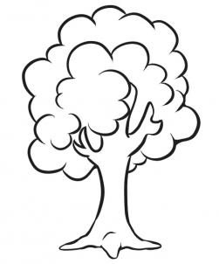 **= 5000 trees**

|  |  |
| --- | --- |
| **VILLAGE A** | http://cdn.imgs.steps.dragoart.com/how-to-draw-a-simple-tree-step-5_1_000000024405_3.jpghttp://cdn.imgs.steps.dragoart.com/how-to-draw-a-simple-tree-step-5_1_000000024405_3.jpg |
| **VILLAGE B** | http://cdn.imgs.steps.dragoart.com/how-to-draw-a-simple-tree-step-5_1_000000024405_3.jpghttp://cdn.imgs.steps.dragoart.com/how-to-draw-a-simple-tree-step-5_1_000000024405_3.jpghttp://cdn.imgs.steps.dragoart.com/how-to-draw-a-simple-tree-step-5_1_000000024405_3.jpg |
| **VILLAGE C** | http://cdn.imgs.steps.dragoart.com/how-to-draw-a-simple-tree-step-5_1_000000024405_3.jpghttp://cdn.imgs.steps.dragoart.com/how-to-draw-a-simple-tree-step-5_1_000000024405_3.jpg |

1. Which village planted the greatest number of trees? (1 mark)
2. How many trees were planted in village A? (2marks )
3. How many trees were planted altogether?(2marks

**END**